Indian School Al Wadi Al Kabir
Assessment 1
SOCIOLOGY (Code:039)

Class: XI Time: 3 Hours
Date:18/09/2022 Max. Marks: 80

General Instructions:
- All sections are compulsory.
- The question paper consists of two sections:
Section A – Objective Type Questions or OTQ’s which consists of 14 MCQ’s and a Passage comprehension of 3 questions
Section B- Subjective Type Questions or STQ’s which consists of 3 parts:
Answer to the 2mark questions to be given in 30 words
Answer to the 4mark questions to be given in 80 words
Answer 3 long answers, each carrying 6 marks in 200 words
- Marks allotted to each question are indicated in bold

SECTION A: OTQ’s (20 marks)

Q.1 Choose the correct answer from the options given below ((14x1= 14marks)

- Who wrote the book “Sociological Imagination”?
(a) C.W. Mills (b) August Comte (c) Max Weber (d) Karl Marx
- Which one of the following refers to the place or time of one’s birth?
(a) Identity (b) Natal (c) Values (d) Aggregates
- The ‘Age of Enlightenment’
- Established rational thought as central feature of the human being
- Advocated superiority of the church and the king over the masses
- Saw an increase in the modes of production
- Brought with it rewards for hard work & social mobility

- The economic system in which highly complex division of labour is present is the feature of ______(a) modern societies (b) simple societies (c) globalization (d) rural economy
- Macro-sociology is the study of:
(a) small groups (b) large groups (c) minorities (d) tribal groups
- A Peer group is a kind of
(a) Primary group (b) Secondary group (c) Association (d) Aggregate
- The behaviours, obligations, and privileges attached to social status is known as
(a) Status set (b) Role set (c) Social role (d) Status symbol
- The family in which person is married is known as
(a) family of procreation (b) family of orientation (c) nuclear family (d) joint family
- The French Revolution announced the arrival of
- Economic prosperity and well-being (b) industrialization and modernization
(c) scientific inventions & technological progress
(d) political sovereignty at the level of individuals and nation-states

- The basis of a caste system is
(a) Ascribed status (b) Achieved status (c) Power (d) Wealth
- One of the features of modern societies is
(a) specialization of work (b) face to face interaction of members
(c) urbanization and factory production (d) agricultural production
- Slums in urban areas denote
(a) division of labour (b) overpopulation and migration (c) education and development (d) illiteracy
- During the Industrial Revolution...
- rural artisans made profit (b) urban centers expanded and grew (c) family businesses flourished (d) people migrated from cities to villages

- The form of power considered legitimate is
(a) Authority (b) Political Party (c) Welfare State (d) Sovereignty

Q.2 Read the following passage and answer the questions that follow: (3 x 2= 6 marks)

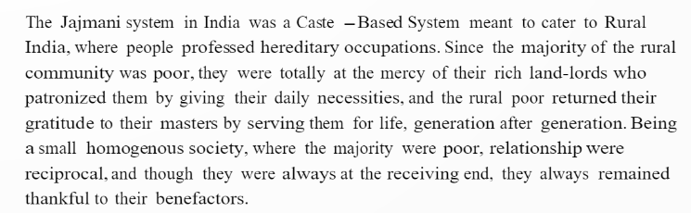

- Answer the following questions based on the above passage:

- What according to you is the Jajmani system?
- What do you understand by hereditary occupations?
- Sociologists believe that the Jajmani system denotes bonded labour- which is a kind of slavery. Do you agree or disagree? Analyze the statement and explain it in the context of the Indian caste system.

SECTION B: STQ’s (60 marks)
Q3. Answer to the 2mark questions to be given in 30 words. Attempt any 7 out of the 8 given
(7 x 2= 14)

- Discuss the pluralistic perspective of a society.
- What is power?
- How would you describe primary groups?
- What are the three different types of rights a citizen enjoys?
- How are human society’s different from animal societies?
- How are Sociology and Anthropology related to each other?
- What is social control?
- Explain the term ‘bourgeoisie’.
Q4. Answer to the 4mark questions to be given in 80 words. Attempt any 4 out of the 5 given (4x7 = 28)
- Is sociology a science? Explain
- Discuss relationship between Sociology and Economics
- How ‘Ascribed Status’ is different from ‘Achieved Status’?
- What are the characteristics of a social group?
- What is kinship?
Q5. Answer any 3 long answers, each carrying 6 marks in 200 words. Attempt any 3 out of the 4 given below (3x6=18)

- In what ways did the Industrial Revolution lead to the birth of Sociology in Europe?
- What are social groups? Discuss various types of groups
- What is social control? Do you think the modes of social control in different spheres of society are different? Discuss.
- What is education? Discuss its importance and various forms.
*****************************************************************************

